# **How to change the color of #hb-one-page-bullets**

* **[← Back to discussions](https://hb-themes.com/forum)**
* **Resolved**
* Posted in: [**Highend WP Theme**](https://hb-themes.com/forum/all/forum/highend-wp-theme/)
* 
  + Posts: 45
* **wmubgar**
* FEBRUARY 5, 2016 AT 12:11 PM [#72908](https://hb-themes.com/forum/all/topic/how-to-change-the-color-of-hb-one-page-bullets/#post-72908)
* Hi
* I have not been able to find any way to change the colour of the one page section bullets (#hb-one-page-bullets) in Highend Options, so I tried using:
* #hb-one-page-bullets {
* color: #cccccc;
* }
* in the custom CSS area, but it didn’t work.
* I would be grateful if you would let me know what code to use to achieve the required result.
* Kind regards,
* Wadah
* 
  + Posts: 6593
* Dev Team
* **Kika**
* FEBRUARY 5, 2016 AT 5:09 PM [#72935](https://hb-themes.com/forum/all/topic/how-to-change-the-color-of-hb-one-page-bullets/#post-72935)
* Hey there,
* Please add the following CSS into the Custom CSS field in Highend Options > General Settings:
* #hb-one-page-bullets li a, #hb-one-page-bullets li a.current-item i:before, #hb-one-page-bullets li a:hover i:before {  
   color: #FF0000 !important;  
  }

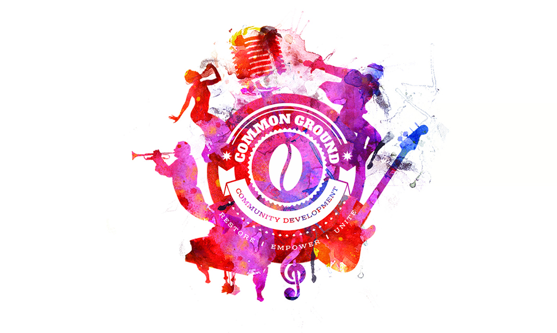

## **About Common Ground CDC**

Common Ground Community Development is a non-profit 501(c)3 tax-exempt organization dedicated to providing community engagement and enrichment through the arts and social entrepreneurism. Our mission is to provide a safe place for individuals to be empowered, restored, and unified.

## **Objectives**

*Our objectives are to develop meaningful programming that:*

• connects people to the arts and community building by providing a space for instruction and collaboration

• imparts coping strategies for those in recovery

• improves artistic and entrepreneurial skills

• enhances individual’s self-worth

• creates a sense of acceptance and belonging

## **Meet The Team**

Maeva Renaud, Executive Director, maeva@cglakeworth.org

Kelly Olive, Creative Arts Academy Director, kelly@cglakeworth.org

Kirstyn Witzer, CAA Program Administrator, kirstyn@cglakeworth.org

Nicole Straussman, Lake Worth Kids Choir Director, nicole@cglakeworth.org

Justin Olive, Common Grounds Coffee Bar Director, justin@cglakeworth.org



[Learn More >](http://commongroundscoffeebar.com/)

[](http://commongroundscoffeebar.com/)

[Learn More >](http://www.cglakeworth.org/where-to-buy.php)

[](http://www.cglakeworth.org/where-to-buy.php)

[Learn More >](http://impartthearts.com/)

[](http://impartthearts.com/)

[Learn More >](http://www.cglakeworth.org/Events.php)







### **Common Ground Community Developement**

21 J Street, Lake Worth, FL

Monday-Friday: 8:00 am - 7:00 pm

Sat: 8:00 am - 10:00 pm

Sun: 12:00 pm - 7:00 pm

### **MAEVA RENAUD**

EXECUTIVE DIRECTOR

25 South J Street, Lake Worth, FL 33460

DIRECT: 305.297.9247

OFFICE: 561.247.7621

MAEVA@CGLAKEWORTH.ORG

[www.cglakeworth.org](http://www.cglakeworth.org/)

Maeva Renaud, Executive Director, maeva@cglakeworth.org

Kelly Olive, Creative Arts Academy Director, kelly@cglakeworth.org

Kirstyn Witzer, CAA Program Administrator, kirstyn@cglakeworth.org

Nicole Straussman, Lake Worth Kids Choir Director, nicole@cglakeworth.org

Justin Olive, Common Grounds Coffee Bar Director, [justin@cglakeworth.org](http://kirstyn@cglakeworth.org/)